**Effect of Group membership on time perception**

Mukesh B. Makwana, ShrutiTewari, and Narayanan Srinivasan

Centre of Behavioural and Cognitive Sciences, University of Allahabad, Allahabad, India

**Abstract:**

Time perception is important in performing everyday activities including effective social interactions. Many factors are known to influence our sense of time but the effect of social context is less extensively studied. Srinivasan et al. (2013) using retrospective temporal reproduction paradigm showed that participants perceived the duration of the ambiguous sound clip to be longer when primed with relevant social context (mela) compared to irrelevant social context (city) and this effect was seen only when the prime was given before the participants listened to the sound clip. Moreover, in their next study Srinivasan et al. (2014) using a prospective temporal reproduction paradigm showed that attention mediates this social priming effect. We in the present study aimed to extend this social priming effect on duration perception beyond the mela context and old age population into a more general group membership context (Hindu festival/ Muslim festival) with a population of younger adults (Experiment 1). We also aimed to study this social priming effect in a more controlled laboratory environment using temporal reproduction at four different levels of duration viz.1 sec, 5 sec, 10 sec and 20 sec (Experiment 2) instead of one level of duration as in all previous studies i.e., 20 sec**.** Results suggest that Hindu participants reproduced longer duration when they were primed with Hindu festival compared to Muslim festival. However, for Muslim participants the reproduced duration was not significantly longer than Hindu festival priming although it showed the trend. Results from Experiment 2 demonstrate that the social priming effect on temporal reproduction becomes stronger for longer duration. Results reveal that maximum effect occurs for 20 sec. As different mechanisms exist for short and long duration perception we suggest that influence of social priming effect using temporal reproduction paradigm is mediated via mechanisms involved in the perception of longer durations. Further studies are needed to test the social priming effect on time perception using different measures of time estimation.

**Background:** According to the ‘new look’ approach our perception is highly influenced by context (Bruner, 1957). What we see and perceive is not only modulated by the contents of perception but also by the context and its relevance in that context. Srinivasan et al. (2013) explored the effect of this social relevance on time perception in the Magh Mela context. They used a retrospective temporal reproduction paradigm. They found that pilgrims (Kalpwasi) perceived the duration of 20 sec ambiguous sound clip to be longer when told that the sound was recorded in the Mela compared to when they were told that the sound was recorded in the city. Srinivasan et al. (2014) not only replicated their finding using prospective temporal reproduction paradigm but also established that ‘attention’ is necessary for this effect. Following these studies we understand that social factors do influence time perception but there are further interesting questions which are not stated in the studies conducted above.

1) Does this Mela-related social context effect also exist for other social factors like group membership? 2) Does this effect which was only studied in older participants also holds true for young adults? 3) Does this effect also exist for other time scales like 1 sec, 5sec, and 10 sec? To answer these questions we designed the following two experiments.

**Experiment 1: Effect of group membership on time perception**

**Stimuli:** A 20 second long ambiguous sound clip was prepared by mixing the sounds recorded from various Hindu and Muslim festivals along with noise from city traffic and white noise to make it ambiguous.

**Procedure:** We used a similar paradigm as Srinivasan et al. (2014). The experiment was a between subjects design with two groups viz. Hindus and Muslims and two priming conditions viz. Hindu festival priming and Muslim festival priming resulting in four groups/conditions (Hindu group-Hindu festival primed, Hindu group-Muslim festival prime, Muslim group-Muslim festival prime, and Muslim group-Hindu festival prime). Participants first listened to the sound clip via a headphone and then reproduced its duration using a stopwatch whose dial was not visible to the participants. After the temporal reproduction participants were asked to describe the sound clip and were also asked to recall the prime (prime check).

**Hypothesis:** Like Mela primed sound clip is more relevant in Mela context, sound clip primed by in-group festivals will be more relevant compared to sound clip primed by out-group festival. Hypothesis suggests that participants would reproduce longer durations when primed with in-group festival.

**Results and Discussion:** The main effect of religion was significant *F* (1, 100) = 7.44, *p*< .05, with Hindus reproducing a shorter duration than Muslims. The main effect of prime was significant *F* (1, 100) = 4.204, *p*< .05 with longer reproduction for in-group priming. The interaction between religion and priming condition was also significant, *F* (1, 100) = 14.901, *p*< .001. Post hoc analysis with Bonferroni correction revealed a strong in-group priming effect with Hindu participants, [*t* (46) = 4.027, *p* < .05] but not with Muslims [*t* (46) = 1.332, *p* > .05] even though they showed somewhat similar trend. Weaker priming effect for Muslim participants can be explained by familiarity, as Muslims participants are more familiar with Hindu festival. Hence they showed longer reproduced duration for both the priming conditions, but further studies are needed to confirm this hypothesis.

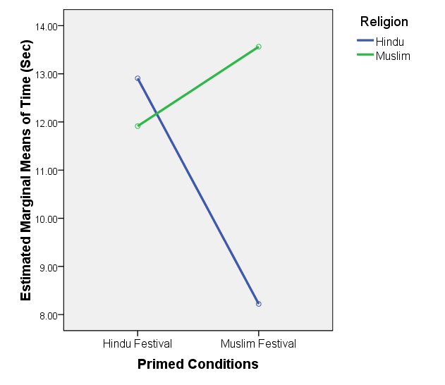

Figure 1: Results of experiment 1 showing the mean reproduced duration values by two religious populations (Hindu and Muslim) for two contextual priming (Hindu festival and Muslim festival).

**Exp 2: Effect of in-group priming with multiple levels of duration**

As we established the effect of group membership on time perception in Experiment 1 we performed the Experiment 2 with only Hindu population and two priming condition (Hindu festival/ Muslim festival). This study would answer whether the social priming related effect on duration perception exists only for 20 sec duration or also for other levels of duration like1 sec, 5 sec and 10 sec. We used a mixed design with religious priming as between subject factor and duration as within subject factor i.e. Religious priming (Hindu festival/ Muslim festival) X Duration (1 sec, 5 sec, 10 sec, and 20 sec).

**Stimuli:** We used the same ambiguous sound clip as in Experiment 1 and cut it into 4 durations i.e. 1 sec, 5 sec, 10 sec, and 20 sec.

**Procedure:** Participants sat in the dimly light room in front of the computer. Experiment was designed and responses were collected using E-prime software. Each participant after primed with either Hindu festival or Muslim festival was randomly presented with 20 trials (4 duration X 5 repeats). At the end of each trial they were supposed to reproduce the duration by pressing the spacebar key. At the end of experiment participants were asked to describe the sound clip and were also asked to recall the prime (prime check).

**Hypothesis:** As different mechanisms exists for perception of short and long duration and given the strong group membership effect on time perception for 20 seconds stimuli in the previous experiment. We hypothesized that the in-group priming effect would be stronger for longer duration compared to shorter durations.

**Results and discussion:**

The main effect of Prime was significant *F* (1, 37) = 4.22, *p*<.05, *ηp2*=0.103. Participants reproduced longer duration when primed with Hindu festival compared to Muslim festival thus demonstrating the group membership effect on time perception. The main effect of different levels of duration was also significant, *F* (3,111) = 341.91, *p*<.0001, *ηp2* =0.902. Reproduced duration correlated with the actual duration indicating that participants were able to perform the task well. Also the interaction between Prime and Levels of duration was significant, *F* (3,111) = 5.339, *p*<.05, *ηp2* =0.126. Post Hoc analysis with Bonferroni correction revealed the stronger effect of priming only for 20 sec duration *t* (37) = 5.469, *p* <0.05 [95% CI of difference, +1.708 to +4.670] although there was a trend for 10 sec duration. In general the magnitude of priming effect increased with the temporal length of the duration. Although other measures of time estimation need to be tested to confirm this hypothesis.

Exp2_HM.tif

Figure 2: Results of experiment 2 showing the mean reproduced duration values by Hindu participants for two contextual priming (Hindu festival and Muslim festival) and four levels of duration (1 sec, 5 sec, 10 sec, 20 sec).

**Conclusion:**

We not only extended the previous results of social context priming on duration perception to a general group membership effect but also demonstrated the effect with younger population. We also showed that the effect is stronger for 20 sec duration. In Experiment 1 participants from Hindu group perceived the duration to be longer when they were told that the sound clip is from Hindu festival compared to the other Hindu group who were told that sound clip is from Muslim festival. Similar trend was also seen for the Muslim participants although not significant. Thus experiment 1 demonstrated the effect of in-group priming effect on duration perception. Muslim participants showed longer reproduction for both Hindu festival as well as Muslim festival priming. This could be explained via familiarity effect, because Muslims participants are more familiar with Hindu festival as Hindus occur in majority. Experiment 2 showed that the in-group priming effect is stronger for 20 sec duration compared to other durations (1 sec, 5 sec, and 10 sec). Further studies are needed to completely understand that how the in-group priming effect influences duration perception.

**References:**

Bruner, J. (1957). On perceptual readiness.*Psychological Review, 64*, 123–152.

Srinivasan, N., Hopkins, N., Reicher, S. D., Khan, S. S., Singh, T., & Levine, M. (2013). Social meaning of ambiguous sounds influences retrospective duration judgments. Psychol. Sci., 24, 1060–1062.

Srinivasan, N., Tewari, S., Makwana, M., & Hopkins, N. (2014). Attention mediates the effect of context-relevant social meaning on prospective duration judgments. *Timing and Time Perception*. epub